**OOP ASSESEMENT**

SAMNA KHALID

SAP: 59736

. Lab Task

Task 1: Abstraction

package bankaccountt;

abstract class BankAccount {

protected double balance;

public abstract double calculateInterest();

public void showBalance() {

System.out.println("Current balance: Rs" + balance);

}

public void setBalance(double balance) {

this.balance = balance;

}

}

class SavingsAccount extends BankAccount {

private static final double INTEREST_RATE = 0.04;

@Override

public double calculateInterest() {

return balance * INTEREST_RATE;

}

}

class CurrentAccount extends BankAccount {

private static final double INTEREST_RATE = 0.01;

@Override

public double calculateInterest() {

return balance * INTEREST_RATE;

}

}

public class Main {

public static void main(String[] args) {

BankAccount savings = new SavingsAccount();

BankAccount current = new CurrentAccount();

savings.setBalance(70000.00);

current.setBalance(80000.00);

double savingsInterest = savings.calculateInterest();

System.out.println("Interest earned on Savings Account: Rs" + savingsInterest);

savings.showBalance();

double currentInterest = current.calculateInterest();

System.out.println("Interest earned on Current Account: Rs" + currentInterest);

current.showBalance();

}

}

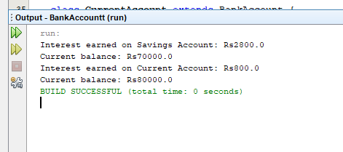

Task 2: Interface

package paymentmethod;

interface PaymentMethod {

void pay(double amount);

void refund(double amount);

}

class CreditCard implements PaymentMethod {

@Override

public void pay(double amount) {

System.out.println("Processing credit card payment of Rs" + amount + ".");

}

@Override

public void refund(double amount) {

System.out.println("Processing credit card refund of Rs" + amount + ".");

}

}

class Paypal implements PaymentMethod {

@Override

public void pay(double amount) {

System.out.println("Processing PayPal payment of Rs" + amount + ".");

}

@Override

public void refund(double amount) {

System.out.println("Processing PayPal refund of Rs" + amount + ".");

}

}

public class Main {

public static void main(String[] args) {

PaymentMethod creditCard = new CreditCard();

PaymentMethod paypal = new Paypal();

creditCard.pay(100.00);

creditCard.refund(50.00);

paypal.pay(200.00);

paypal.refund(75.00);

}

}

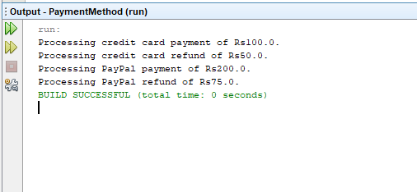

Task 3: Method Overloading

package discountcalculator;

class DiscountCalculator {

public double applyDiscount(double price, double discountPercent) {

double discountAmount = price * (discountPercent / 100);

return price - discountAmount;

}

public double applyDiscount(double price, double discountPercent, double memberDiscount) {

double discountedPrice = applyDiscount(price, discountPercent);

double memberDiscountAmount = discountedPrice * (memberDiscount / 100);

return discountedPrice - memberDiscountAmount;

}

public double applyDiscount(double price) {

return applyDiscount(price, 5);

}

}

public class Main {

public static void main(String[] args) {

DiscountCalculator calculator = new DiscountCalculator();

double price1 = 900.00;

double discountPercent1 = 20.0;

double finalPrice1 = calculator.applyDiscount(price1, discountPercent1);

System.out.println("Final price after applying " + discountPercent1 + "% discount: Rs" + finalPrice1);

double price2 = 800.00;

double discountPercent2 = 15.0;

double memberDiscount = 10.0;

double finalPrice2 = calculator.applyDiscount(price2, discountPercent2, memberDiscount);

System.out.println("Final price after applying " + discountPercent2 + "% discount and " +

memberDiscount + "% member discount: Rs" + finalPrice2);

double price3 = 550.00;

double finalPrice3 = calculator.applyDiscount(price3);

System.out.println("Final price after applying default 5% discount: Rs" + finalPrice3);

}

}

